**Lab Assignment 4**

**Harish Kolla**

**Class Id: 44**

This is an android application which has a Login page, registration page and an interaction api which converts speech to text.

**Wireframes:**

**Login Page:**

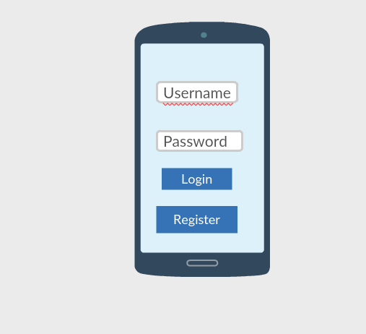

**Registration Page:**

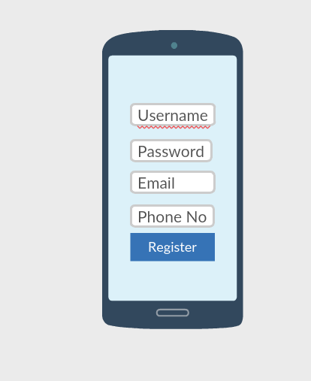

**Interaction page:**

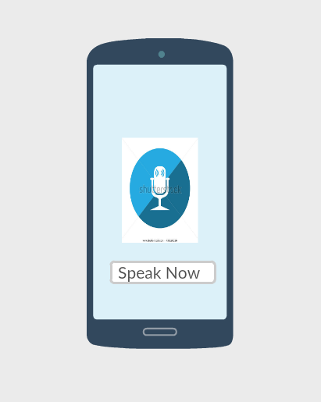

**Output page:**

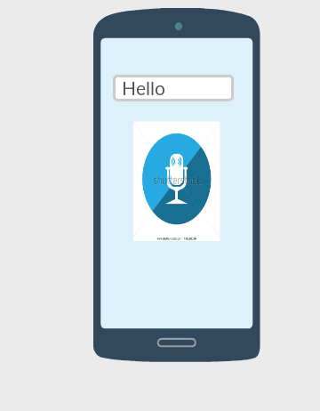

**Screenshots:**

**Login Page:**

This page contains two text fields to enter username and password, on clicking on login button it will check the credentials. Enter the username as admin and password as admin if the credentials are valid then it will direct to the text to speech conversion page. It also contains signup/register button to a new user to signup.

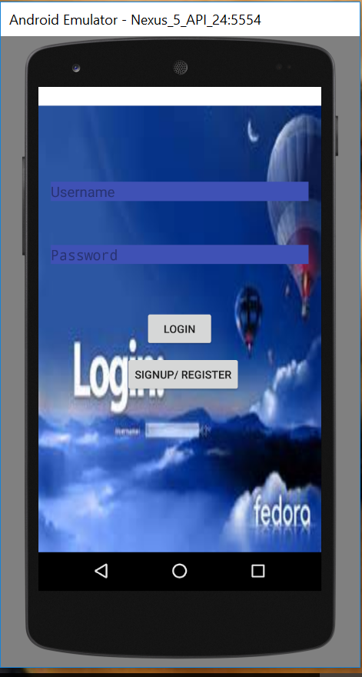

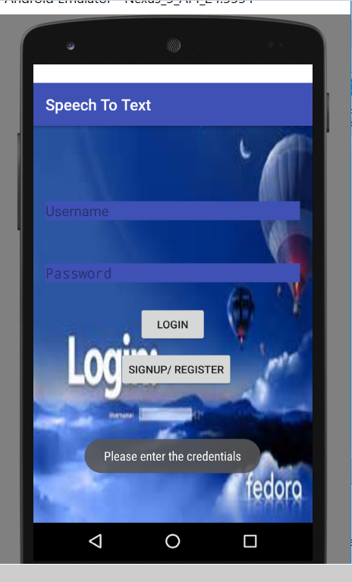

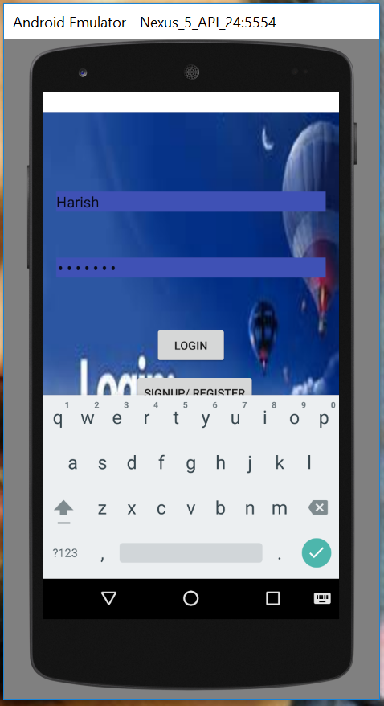

**Registration Page:** This page is used to signup for a new user. It consits of Username, password, email and phone no. After entering the details, on click of register button, it takes to the login page for logging into the interaction page.

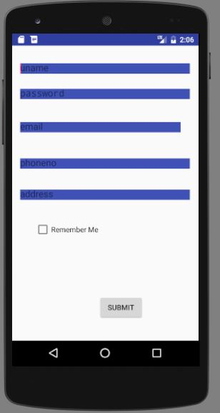

**SpeechtoTextConversion Page:**

This page contains an image, On clicking the image, it waits for the speaker’s speech and then this is converted to text. If the speaker doesn’t speak anything , it shows a dialog “Didn’t catch that, Try speaking Again”.

